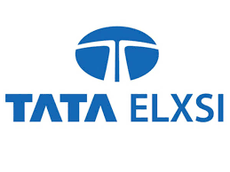

**General Overview**

Tata Elxsi Ltd, the product design arm of the multi-billion Tata Group, was incorporated in March 30th, 1989 as Tata Elxsi (India) Ltd. The company provides product design and engineering services to the consumer electronics, communications and transportation industries and systems integration and support services for enterprise customers. It provides digital content creation for media and entertainment industry. The company is having their state-of-the-art design centers and operates through delivery centers in Bangalore, Pune, Chennai Mumbai and Thiruvananthapuram. It has only one subsidiary, namely Tata Elxsi (Singapore) Pte Ltd.

The Company operates in two segments, namely Software Development and Services, and Systems Integration and Support. The businesses constituting Software Development and Services segment are embedded product design services (design and development of hardware and software), innovation design engineering (mechanical design with a focus on industrial design) and visual computing labs division. Systems Integration and Support offers a range of technical computing solutions spanning high-end computing platforms, networking, mechanical design automation tools, enterprise storage solutions, digital media and life sciences solutions through their tie-ups with global leaders in these respective areas.

The company commenced their business on May 5, 1989. They undertook the role of being the focal point for the entry of the Tatas into high-technology fields by promoting new projects and companies in communications, oil fields services, process control, management systems, financial services, advanced materials and composites. In the year 2000, the shares of the company were acquired by the Tata Sons the main holding company of the Tata group.

**Shareholding Pattern of the company**

The Shareholding Pattern page of Tata Elxsi Ltd. presents the Promoter's holding, Foreign Institutions Investment’s (FII) holding, Domestic Institutions Investment’s (DII) holding, and Shareholding by general public etc.

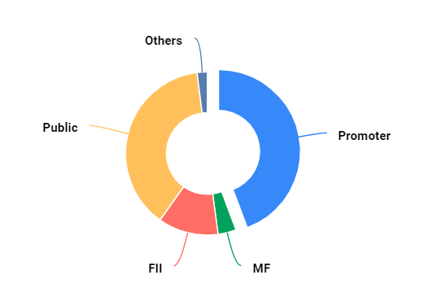

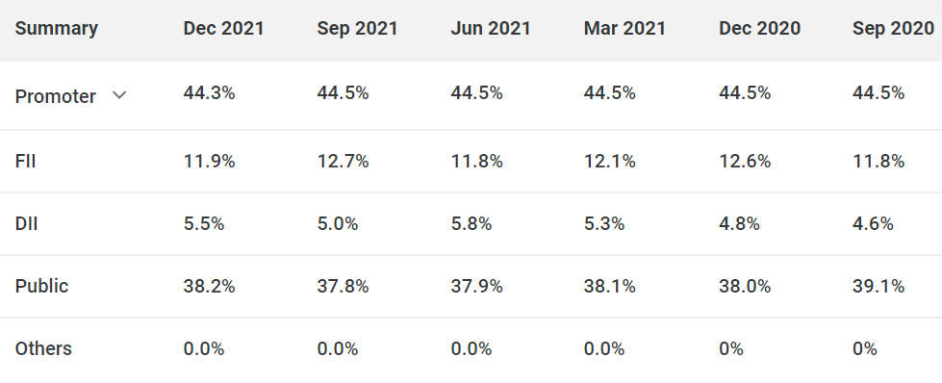

**Management of the company**

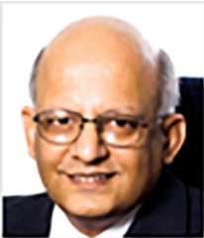

**Mr. N. Ganapathy Subramaniam - Chairman (Non-Executive and Non-Independent)**

Mr. N. Ganapathy Subramaniam is the Chairman (Non-Executive and Non-Independent) of Tata Elxsi Limited since November 2014. He is also the Chief Operating Officer (COO) of TCS since February 2017. Prior to taking over the COO’s role he served as the Executive Vice President and Head of TCS Financial Solutions, a strategic business unit of TCS.

Mr. Subramaniam brings in-depth knowledge about technology trends, systems, and policies of leading global corporations, and international business. He actively participates in banking, technology, and business forums in addition to specific knowledge streams in risk management and Six Sigma orientation.

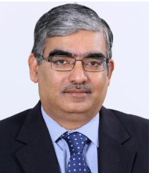

**Manoj Raghavan - CEO & Managing Director**

Manoj Raghavan is the CEO & Managing Director of Tata Elxsi. He has over 22 years of industry experience. Prior to taking over the role of CEO & MD, he served as the Executive Vice President and Head of the Embedded Product Design (EPD) division, spearheading the sales, overall delivery, and P&L for this division.

He joined Tata Elxsi in 1997 as Regional Manager to set up and grow Japan operations. Subsequently, he was also responsible for developing the business in South Korea, Taiwan, Singapore, and China. More recently, Manoj was responsible for the North American business and helped grow the region to become a top revenue earner for the company. Manoj Raghavan holds a B.Tech in Metallurgical Engineering from IIT Madras, an MBA from The Indian Institute of Foreign Trade, New Delhi, and has completed the Advanced Management Program from Harvard Business School.

**SWOT analysis of the company**

**1. Strengths of Tata Elxsi**

Strengths are an organization’s distinct skills that offer it a competitive edge in gaining greater market share, attracting more customers, and maximising profitability. Tata Elxsi’s strengths are listed below:

* Success of new product mix - Tata Elxsi provides exhaustive product mix options to its customers. It helps the company in catering to various customers segments in the Software & Programming industry.
* Talent management at Tata Elxsi and skill development of the employees - Human resources are integral to the success of Tata Elxsi in Software & Programming industry.
* Track record of innovation - Even though most players in the Technology strive to innovate, Tata Elxsi has successful record at consumer driven innovation.
* Wide geographic presence - Tata Elxsi has extensive dealer network and associates’ network that not only help in delivering efficient services to the customers but also help in managing competitive challenges in Software & Programming industry.
* Market Leadership Position - Tata Elxsi has a strong market leadership position in the Software & Programming industry. It has helped the company to rapidly scale new products successes.
* Brands catering to different customers segments within Software & Programming segment - Tata Elxsi extensive product offerings have helped the company to penetrate different customer segments in Software & Programming segment. It has also helped the organization to diversify revenue streams.

**2. Weaknesses of Tata Elxsi**

Weaknesses of Tata Elxsi can either be absence of strengths or resources of capabilities that are required but at present the organization doesn't have. Leaders have to be certain if the weakness is present because of lack of strategic planning or as a result of strategic choice

* Gross Margins and Operating Margins which could be improved and going forward may put pressure on the Tata Elxsi financial statement.
* Niche markets and local monopolies that companies like Tata Elxsi able to exploit are fast disappearing. The customer network that Tata Elxsi has promoted is proving less and less effective.
* Loyalty among suppliers is low - Given the history of Tata Elxsi coming up with new innovations to drive down prices in the supply chain.
* Declining market share of Tata Elxsi with increasing revenues - the Software & Programming industry is growing faster than the company. In such a scenario Tata Elxsi has to carefully analyse the various trends within the Technology sector and figure out what it needs to do to drive future growth.
* High cost of replacing existing experts within the Tata Elxsi. Few employees are responsible for the Tata Elxsi's knowledge base and replacing them will be extremely difficult in the present conditions.
* High turnover of employees at the lower levels is also a concern for the Tata Elxsi. It can lead to higher salaries to maintain the talent within the firm.

**3. Opportunities for Tata Elxsi**

Opportunities are potential areas where the firm can identify potential for - growth, profits, and market share.

* Opportunities in Online Space - Increasing adoption of online services by customers will also enable Tata Elxsi to provide new offerings to the customers in Software & Programming industry.
* Lower inflation rate - The low inflation rate brings more stability in the market, enable credit at lower interest rate to the customers of Tata Elxsi. This will increase the consumption of Tata Elxsi products.
* Customer preferences are fast changing - Driven by rising disposable incomes, easy access to information, and fast adoption of technological products, customers today are more willing to experiment / try new products in the market. Tata Elxsi has to carefully monitor not only wider trends within the Software & Programming industry but also in the wider Technology sector.
* Rapid Expansion of Economy as the US economy is improving faster than any other developed economy, it will provide Tata Elxsi an opportunity to expand into the US market. Tata Elxsi already have know-how to operate into the competitive US market.
* Accelerated technological innovations and advances are improving industrial productivity, allowing suppliers to manufacture vast array of products and services. This can help Tata Elxsi to significantly venture into adjacent products.
* Trend of customers migrating to higher end products - It represents great opportunity for Tata Elxsi, as the firm has strong brand recognition in the premium segment, customers have experience with excellent customer services provided by Tata Elxsi brands in the lower segment. It can be a win-win for the company and provides an opportunity to increase the profitability.

**4. Threats to Tata Elxsi**

Threats are factors that can be potential dangers to the firm's business models because of changes in macro-economic factors and changing consumer perceptions. Threats can be managed but not controlled.

* Commoditization of the product segment - The biggest challenge for Tata Elxsi and other players in the industry is the increasing commoditization of the products in Technology industry.
* Changing political environment with US and China trade war, Brexit impacting European Union, and overall instability in the middle east can impact Tata Elxsi business both in local market and in international market.
* Saturation in urban market and stagnation in the rural markets - For Tata Elxsi this trend is an ongoing challenge in the Software & Programming segment. One of the reasons is that the adoption of products is slow in rural market. Secondly it is more costly for Tata Elxsi to serve the rural customers than urban customers given the vast distances and lack of infrastructure.
* Shortage of skilled human resources - Given the high turnover of employees and increasing dependence on innovative solution, company name can face skilled human resources challenges in the near future.
* Trade Relation between US and China can affect Tata Elxsi growth plans - This can lead to full scale trade war which can hamper the potential of Tata Elxsi to expand operations in China.
* Changing demographics - As the baby boomers are retiring and new generation finding hard to replace their purchasing power. This can lead to higher profits in the short run for Tata Elxsi but reducing margins over the long run as young people are less brand loyal and more open to experimentation.

**Competitive Analysis**

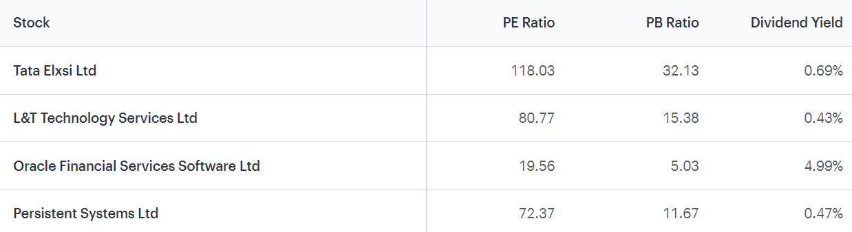

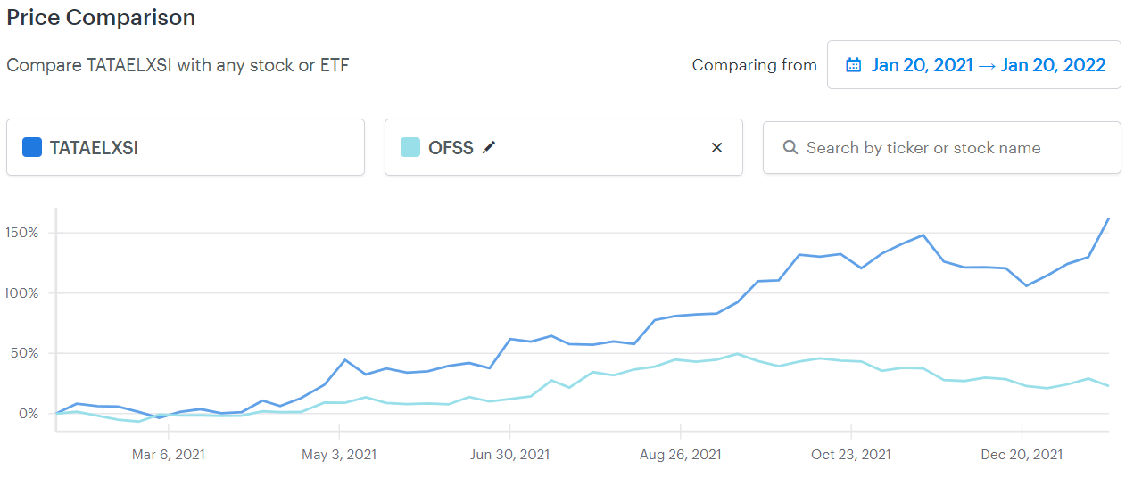

**Conclusion and way forward for the company**

Tata Elxsi provides integrated services – from research and strategy, to electronics and mechanical design, software development, validation and deployment, and is supported by a network of design studios, global development centers and offices worldwide.

And moving we can expect more innovation and growth from the company. The investment checklist for the company shows the following findings:

* Current price is more than the intrinsic value
* Stock has been generating better return on equity than bank FD
* Stock offers good dividend returns
* Good time to consider, as stock is not in overbought zone
* Stock not in ASM/GSM lists and not a lot of promoters holding is pledged